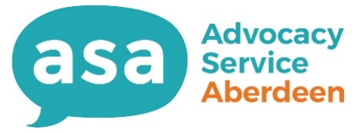

Role Title:
Advocacy Volunteer
Supported by:
You will be directly supported by our Volunteer Coordinator.
Aim of the role:
- To provide an independent advocacy service for people living in Aberdeen City.
- To help people feel better prepared and able to engage with social care’ health care and housing professionals.
- To help people within settings where their rights and liberties may be impacted on.

What to expect:
Advocacy seeks to help people have a say in what matters to them and to have these views understood and considered by others. Advocacy empowers people through making no judgement on their choices, wishes or views and advocacy workers will only act following an instruction from those they work with.

Advocacy work can be quite varied and you will have the opportunity to help people within different areas where they can potential be disempowered. We work with different groups of peoples across lots of different communities. Areas of our work include Learning Disabilities, Mental Health Disorders, Victims of Domestic Abuse, Carers, Older Adults, Self-Directed Support and Children and Young People.

We work across a range of areas which can include Guardianship order applications, Children’s Hearings, Child Protection Case Conferences, Mental Health Tribunals, Complaints about Local Authority or NHS services, Appointments with GPs, Social Workers and Consultants, Adult Support and Protection Case Conferences and to help people seek care and support services.

Volunteers will have access to shadowing, training and on-going support from the volunteer coordinator and the rest of the team.

